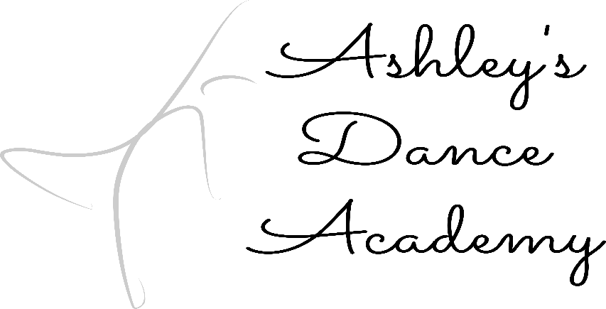
Registration Prices: Registration is due when signing dancer(s) up for classes
1 Student: $40.00 - 2 Student: $60.00 - 3 Student: $75.00
4 Student & More: $85.00
Combo Options: Dancer may choose two to three classes for the combo

IRISH STEP DANCING: Dancer must take soft shoe to take hard shoe.
(Soft Shoe can be taken alone).

Pointe’: Pointe may only be taken if you have taken it last year. If you wish to work towards pointe, you may sign up for classical ballet.

4 Washington Ave. E Albia, Iowa 52531
641.799.4569 ashleysdanceacademy@yahoo.com
www.ashleysdanceacademy.com

Check classes that apply!
Age 4: Combo Options: ☐ BALLET – ☐TAP - ☐JAZZ
Ages 5 – 8: Combo Options: ☐BALLET –☐ TAP –☐ JAZZ
☐HIP HOP ☐ POMS IRISH STEP DANCING: ☐ SOFT SHOE
☐ HARD SHOE ☐ CLASSICAL BALLET
Ages 9 – 12: Combo Options: ☐LYRICAL –☐ TAP –☐ JAZZ
IRISH STEP DANCING: ☐SOFT SHOE – ☐HARD SHOE
☐HIP HOP ☐ POMS ☐ CLASSICAL BALLET
JUNIOR HIGH – HIGH SCHOOL:
Combo Options: ☐CONTEMPORARY –☐ TAP –☐ JAZZ
IRISH STEP DANCING: ☐SOFT SHOE –☐ HARD SHOE
☐HIP HOP ☐ POINTE’ ☐POMS ☐ CLASSICAL BALLET
ADULT: Combo Options: ☐TAP – ☐HIP HOP -- ☐ CONTEMPORARY

________________
3 Benton Ave. E
Albia, Iowa 52531
641.891.2578
shannondance@hotmail.com
www.shannonsschoolofdance.net

Name of Student: Click here to enter text.
Date of Birth: Click here to enter text.
Age:Click here to enter text.
Medical Issues that the Studio Needs to Be Aware of:
Click here to enter text.
Scheduling Conflicts: Click here to enter text.

PARENTS/GUARDIANSClick here to enter text.
MAILING ADDRESS: Click here to enter text.
PHONE NUMBER (1 )Click here to enter text. CONTACT PERSONClick here to enter text.
PHONE NUMBER (2 )Click here to enter text. CONTACT PERSON Click here to enter text.
EMAIL ADDRESS Click here to enter text.
This form must be signed and dated for you or your dancer to be able to participate in dance class.
Signature: Click here to enter text. Date:Click here to enter text.

